Yeast Clusters:

Cluster 1: -0.2413 -0.1288 0.0622 0.1734 0.2179 1.6517 1.9053
Cluster 2: -0.9535 -1.4716 0.0775 -0.1795 -1.0048 1.1512 0.9688
Cluster 3: 0.1651 0.0917 -0.1039 -0.5526 -0.6301 -1.7232 -1.7548
Cluster 4: 0.0233 0.2508 -0.277 -0.364 -0.7354 -0.8946 0.7001
Cluster 5: -0.0016 0.1565 0.3563 0.7016 1.0097 1.8423 1.6434
Cluster 6: -0.0393 0.1539 0.4361 1.1058 1.4487 3.0163 2.8294

Order for Utilities:

12 21 23
10 13 24
4 24 25
7 23 26
20 25 27
14 19 28
1 18 29
15 26 30
28 29 31
2 27 32
8 16 33
30 32 34
22 34 35
9 31 36
35 36 37
6 37 38
3 38 39
33 39 40
17 40 41
11 41 42
5 42 43

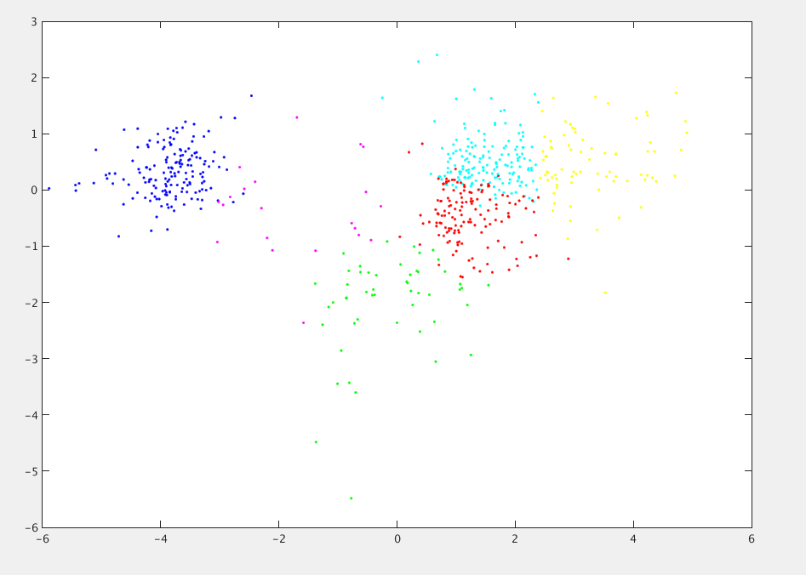

Codes:

private static void run_hierarch(ArrayList<ArrayList<Double>> data) {
// System.out.println("Running hierarchical algorithm...");
ArrayList<ArrayList<Double>> distance_matrix = new ArrayList<ArrayList<Double>>();
ArrayList<Integer> removed_clusters = new ArrayList<Integer>();

// First, we create a distance matrix
for(int i = 0; i < data.size(); i++)
{
distance_matrix.add(new ArrayList<Double>());
for(int j = 0; j < data.size(); j++)
{
distance_matrix.get(i).add(euclidean_dist(data.get(i),data.get(j)));
}
}

// Next, the actual algorithm
while(removed_clusters.size() < distance_matrix.size()-1)
{
// First, we must find the two clusters with the smallest distance
double min = 90000;
int row = 0;
int col = 1;
for(int i = 0; i < distance_matrix.size(); i++)
{
if (!removed_clusters.contains(i))
{
for(int j = i + 1; j < distance_matrix.size(); j++)
{
if (!removed_clusters.contains(j))
{
if(distance_matrix.get(i).get(j) < min)
{
min = distance_matrix.get(i).get(j);
row = i;
col = j;
}
}
}
}
}

System.out.println((row+1) + "\t" + (col+1) + "\t" + (distance_matrix.size()+1));

removed_clusters.add(row);
removed_clusters.add(col);

// Add new cluster to distance matrix
distance_matrix.add(new ArrayList<Double>());
for(int i = 0; i < distance_matrix.size()-1; i++)
{
distance_matrix.get(distance_matrix.size()-1).add(Math.min(distance_matrix.get(row).get(i),distance_matrix.get(col).get(i)));
}
for(int i = 0; i < distance_matrix.size(); i++)
{
distance_matrix.get(i).add(Math.min(distance_matrix.get(row).get(i),distance_matrix.get(col).get(i)));
}

} // end while loop
}

private static int[] run_kmeans(ArrayList<ArrayList<Double>> Data, ArrayList<ArrayList<Double>> Centroids, int iterations)
{
ArrayList<ArrayList<Double>> NewCentroids = Centroids;

// Stores, for each point, which cluster it is in
int[] cluster_assignment = new int[Data.size()];

// Loop for each iteration: assign points, then reassign cluster centroids
for(int iter = 0; iter < iterations; iter++)
{
// Loop for each point
for(int point = 0; point < Data.size(); point++)
{
double closest_dist = euclidean_dist(Data.get(point), NewCentroids.get(0));
// System.out.println(closest_dist);
int closest_cen = 0;

// Loop for remaining centroids
for(int cen = 1; cen < NewCentroids.size(); cen++)
{
double dist = euclidean_dist(Data.get(point),NewCentroids.get(cen));
if (dist < closest_dist)
{
closest_dist = dist;
closest_cen = cen;
}
}
cluster_assignment[point] = closest_cen;
}
//for(int x = 0; x < cluster_assignment.length; x ++){ System.out.println(cluster_assignment[x]);}
NewCentroids = reassign_centroids(NewCentroids, Data,cluster_assignment);
}

// write the centroids final location
DecimalFormat df = new DecimalFormat("#.####");
for(int i = 0; i < NewCentroids.size(); i++)
{
System.out.print("Cluster " + (i+1) + ": ");
for(int j = 0; j < NewCentroids.get(i).size(); j++)
{
System.out.print(df.format(NewCentroids.get(i).get(j)) + "\t");
}
System.out.print("\n");
}

return cluster_assignment;
}

private static ArrayList<ArrayList<Double>> reassign_centroids(ArrayList<ArrayList<Double>> Centroids, ArrayList<ArrayList<Double>> data, int[] cluster_assignment)
{
ArrayList<ArrayList<Double>> tempCentroids = new ArrayList<ArrayList<Double>>();

// Iterate for each centroid
for (int i = 0; i < Centroids.size(); i++)
{
tempCentroids.add(new ArrayList<Double>());

// Iterate the mean for each axis
for (int axis = 0; axis < Centroids.get(0).size(); axis++)
{
double dist = 0;
int count = 0;

// To find mean, we sum up the value at that axis for each point, then divide by number of points
for (int point = 0; point < data.size(); point++)
{
if(cluster_assignment[point] == i)
{
count ++;
dist = dist + data.get(point).get(axis);
}
}
tempCentroids.get(i).add(dist/count);
}

}
return tempCentroids;
}

private static double euclidean_dist(ArrayList<Double> point1, ArrayList<Double> point2)
{
double sum = 0.0;

for (int i = 0; i < point1.size(); i++)
{
sum = sum + Math.pow(point1.get(i)-point2.get(i),2);
//System.out.println(point1.get(i)+" " + point2.get(i)+ " " + sum);
}
sum = Math.sqrt(sum);
return sum;
}

